***Wanted! Alive or Alive***

**Project Work Design Brief**

**Enrica Zani – matr. 0001004696**

**Alisia Zarbo – matr. 0001004696**

**85575 - Semantic Digital Libraries**

**1° Year DHDK master degree**

**a.a. 2020-21**

Sommario

Intro 4

Context 4

Reference institutions with its institutional goals 4

CH Relevant assets (include raster images or/and panoramas) 6

The target audience with characteristics, motivations, capabilities and devices) 8

The location 8

The concept 8

Specific CH topic selected as case study. Where the idea comes from 8

Chosen cognitive focus among: 1.Attention-Distraction, 2.Language-Narrative, 3. Meaningfulness-Emotions-Empathy, 4. Authenticity perception, 5. Memory-Recall - 2nd step 11

Design cards 11

Conceptual maps 15

The museological approach 15

QUI VA AGGIUNTO UN PICCOLO RIASSUNTO SU: TARGET, SPACE, GOALS, APPROACH 18

Goals (cultural, cognitive, economic, educational, etc.) 18

Requirements 18

Development 19

(a) The story (include an interactive narrative using Twine) 19

PERSONAE 19

SCENARIOS 19

(c) experience design (from the users perspective) (include a diagram)??? 20

(b) Description of the interaction between the project and the users (include Interaction Diagram) 20

Choose your guide 20

Share your Stories 23

~~(c) Development to reach the cognitive focus~~ 24

(c) Foreseen workflow (includes needed software, hardware, professionals) 24

(d) Further development and maintenance issues 25

Search for your pet application 25

Merchandising 25

https://digitalcollection.mypanini.com/ 26

3d print your pet 26

Team roles 26

Enrica Zani and Bigio 26

Alisia Zarbo 26

Bibliography 27

Intro 27

Project 27

In History section (vedere se riusciamo a richiamare le bibliografie dei modals) 28

In Art section 28

Complementary Material for the Discussion 28

3d object or scene (3D): Frida room’s 28

~~Trailer (video)--> NO~~ 28

~~Audio (i.e. interviews of your potential users) --> NO~~ 28

# Intro

[**Wanted!**](https://enri-ca.github.io/WANTED/index.html) is a project --- that have been inspired by a corpus of *lost-pets-advertisements* photographs, collected over the years in various places. It is focused on the complex relationship between humans and their pets in an anti-speciesist view of interpersonal relationship and family's bounds.

The name **Wanted!** obviously comes from the strong visual relationship of these SOS-flyers, analysed in a more detailed way in The Concept paragraph, with the *Old West* bandit bans even if, like the subtitle “Alive or Alive” explains, with different and opposite purposes and intents.

The final website offered to the user, is conceived as a multi-dimensional cultural environment offering different paths to be explored such as a **current virtual exhibition** and **related interactive applications** in the In Art – The Exhibit (link) section, a growing **souvenir-book** built from users’ stories in the Your Stories section as well as a Data section where having access to the preliminary data – such as the already mentioned corpus of *lost-pets-advertisements* photographs - analysed to realize the project.

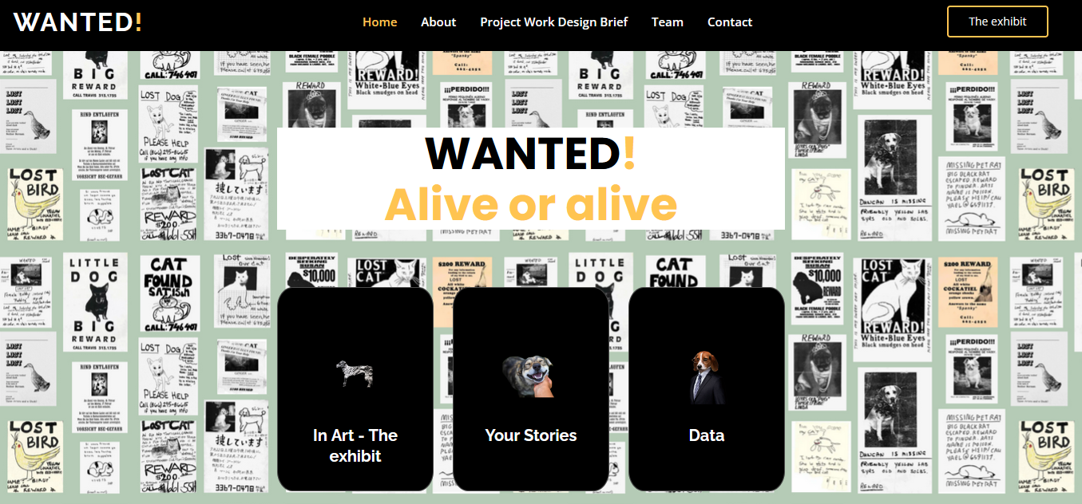

## Context

### Reference institutions with its institutional goals

When we started thinking about this project, as said inspired by a self-collected corpus of photographs, which a sample is in the [Preliminary data section](https://enri-ca.github.io/WANTED/index.html#preliminary_data), the first visual references we thought about had been **memorials** museums and installations such as the [Museo per la Memoria di Ustica](https://www.museomemoriaustica.it/il-museo/) - hosting a Boltanski work, artist specially devoted to memory and memorial issues - or the initially spontaneous [Sacrario partigiani in Piazza Nettuno a Bologna](https://www.storiaememoriadibologna.it/sacrario-partigiani-in-piazza-nettuno-a-bologna-892-opera) - to mention two Bolognese’s examples - or the Argentinian [Archivo Provincial de la Memoria/Ex D2](https://apm.gov.ar/apm/portada). All these institutions are devoted to preserve the public testimony of historical facts as well as to celebrate the intimate memory of missed beloved-ones.  
Although, we soon realized that, even if a strong memorial component was present in our inspirational material, we would also find the way to celebrate the **joyful** part of the relationship with the pets even if - hopefully momentaneously - lost.

For this part we explored some examples such as those mentioned by Simona Caraceni in her Mewselogy course slides (Hermitage cats army guards, [Le chat du Louvre](https://bigcomicbros.net/work/6195/), [Cat Museum Kotor](http://catsmuseum.org/) and Cats Museum Malaysia) and other similar as the [KattenKabinet](https://www.kattenkabinet.nl/) (Cat Cabinet) in Amsterdam: even these references have not been satisfying for our intents, because these museums often celebrated single pets or were too "species-dependent" (celebrating only dogs, or cats, etc.) while we were looking for an institution exploring the complex emotive human-pet relationship "species-independent".

We then realized the [In Art](https://enri-ca.github.io/WANTED/in_art.html) section, conceived as a Virtual Exhibition about this topic: the idea, involving famous visual artists, is to achieve the double goal of humanising the artist and making their emotive world closer to that of the user. We then choose to build an exhibition path on some examples of artists and their pets such as **Frida Kahlo and Granizo**, **Giosetta Fioroni and Petote, Pablo Picasso and Lump, Henry Matisse and Minouche, Salvador Dalí and Babou,** etc.

|  |  |
| --- | --- |
|  |  |
| Sacrario. Bologna 1945 o 1946. Il Sacrario dei caduti della Resistenza in Piazza del Nettuno a Bologna. Credits [Istituzione Bologna Musei](https://www.storiaememoriadibologna.it/crediti) | Virtual exhibition on artist-pet relationships |

The context will be then a Virtual Exhibition about artists-pets relationships as sketched in the [In Art](https://enri-ca.github.io/WANTED/in_art.html) section: the Virtual Exhibition collects different contents –paintings, photographs, books, etc. - belonging to different cultural institutions in order to build a museological path with different way of fruition (a “classic” Virtual Exhibition, interactive applications, 3d artists room exploration, etc.)

The visitor will be also engaged with the possibility of loading and sharing their personal stories in [Your Stories](https://enri-ca.github.io/WANTED/index.html#portfolio) section. A special button in the In Art section will guide rh

Further developments of the project include the forthcoming release of a tool “Search for your pet” able to help proactively people losing their pets by loading, sharing, and visualizing geolocated data of their missing pets and a stronger merchandising proposing funny or educational items to be bought.

**PUT "PACT FRAMEWORK".**

### CH Relevant assets (include raster images or/and panoramas)

We arrived to define that the most suitable context for our purposes was the Virtual Exhibition thanks to a recursive design process using the VisitorBox Ideation Cards https://gifting.digital/visitorbox-design-cards/.

In fact, the cards have been a useful tool to explore the relevant assets and the hypothetical proper target audience for two initial contexts we analysed: a physical museum and the virtual exhibition.

As a reference physical institution, we took the KattenKabinet (Cat Cabinet) in Amsterdam; we used it until the STAGE 3– Create design brief (ancora) to finally decide to design the digital visitor experiences for the Virtual Exhibition.

#### STAGE 1 – Define context

|  |
| --- |
| PHYSICAL REFERENCE INSTITUTION |
|  |

|  |
| --- |
| VIRTUAL MUSEUM |
|  |

The two institutions, as shown in the table below, have in common just the “exhibit” asset and differ basically in the other:

|  |  |
| --- | --- |
| **Physical Museum** | **VE** |
| Retail  location  fame  exibhit* | Guides  digital resource  outreacht activities  exibhit* |

### The target audience with characteristics, motivations, capabilities and devices)

From the same previous step of the Ideation Cards, we could outline that the two institutions had more point of contacts in the target audience than in the assets: in fact, they share the two categories of **art and animal passionate** as well as the part of **users enjoying collections online**. All these audiences are quite **familiar with technological devices** that they are used to use for several daily tasks (find an address, search for a professional, sending and receiving email and instant messaging, etc.)

On these bases, we created the Personae available in the Development section.

|  |  |
| --- | --- |
| **Physical Museum** | **VE** |
| digital visitors  art passionate*  casual tourist  animal passionate* | sofa lovers  art scholars*  skids  passionate with pets* |

### The location

As already mentioned, our VE and applications are thought to be autonomously used online, and according to ??? (Beltramini and Gaiani, 2012: 60). and thus we can use to define it these two categories:

4.Virtual with real: in this category the researchers have identified a type of virtual museum that they define as a digital space built with the use of technology. This virtual space can shape a real space or an ideal space shaped for virtual exhibition. What identifies the virtual museum is that the objects shown are real objects that have been digitalised for display in a virtual space to be better studied or browsed.

5.Virtual with virtual: this last category covers museums with digital spaces that do not exist in reality, and where the objects are also born in digital space (they do not exist in real world), and are created only for the museum. That is to say a completely virtual museum, according to this classification.

## The concept

### Specific CH topic selected as case study. Where the idea comes from

As already introduced, we started from a *lost-pets-advertisements* photographs corpus, collected between 2014 and 2020 in different places around the world. Part of this collection is available in the [Preliminary data section](https://enri-ca.github.io/WANTED/index.html#preliminary_data) where are also available specific pages for three sample flyers (Nobu, Gringo and Luli); in those pages the data, previously spread in the free-text in natural language, have been organized in a table with controlled fields such as the **pet name**, the **type of pet**, some **keywords**.

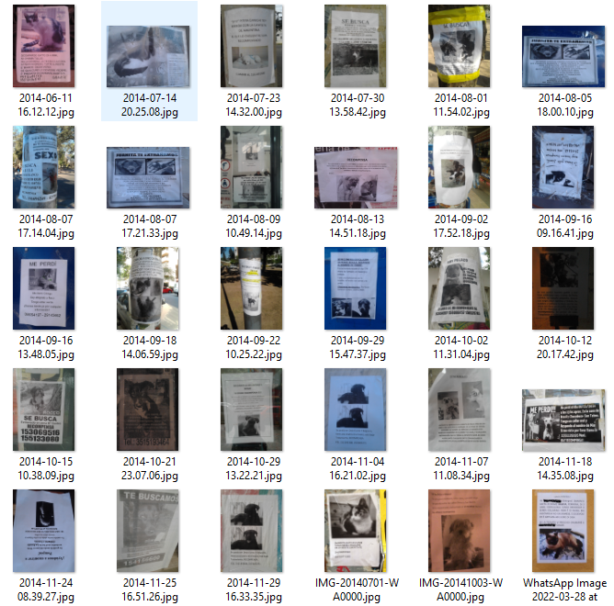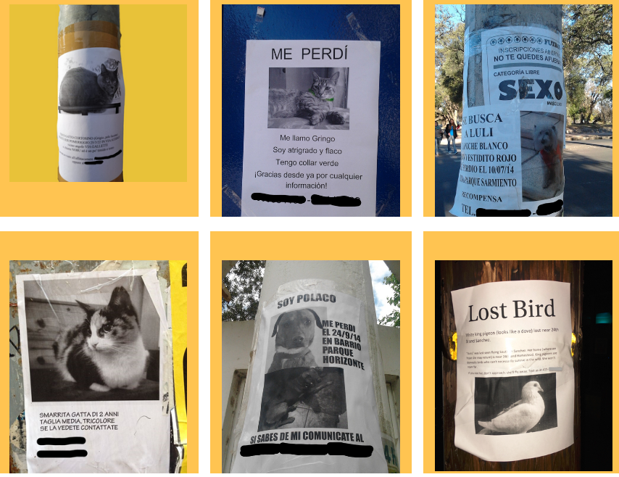

The “preliminary data” have been then used as an observation set through which extracting information to define our *Personae* LINK because we immediately noticed recursive patterns in the composition - both visual and textual - of these leaflets that could be helpful to extract some information about the producers.

#### ANALYSIS on the preliminary data

These repeated features revealed a strong communicative and emotive engagement from “the human” creating the flyer, looking for its lost pets but also trying to share all the love of the relationship and the emotive pain of this missing.

We have been particularly impressed by the sentimental value that most of these flyers express about the affective tie between the lost pet and their humans.

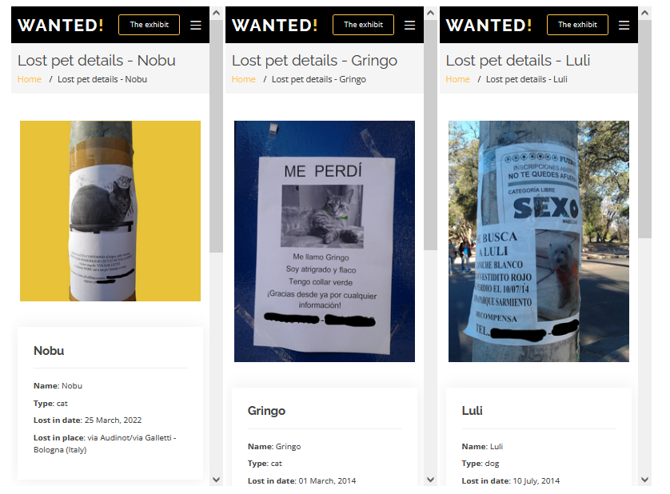

From a **visual viewpoint**, a recursive pattern is the manual intervention of the caregiver to make the visual communication more expressive, putting manually some peculiar colour to a poor A4 b/w laser-printed copy. Examples are shown in the Gringo, Luli and Biyu announcement: “collar verde” or “vestido rojo” “camiseta de argentina”.

From a **textual point of view**, affection diminutives are really common - “caniche” (little dog), “vestidito” (little dress), patitas pechitos.

In addition, Gringo and Polaco are talking in first person “**Me perdì” (I got lost)**; other pets are referred with “ella” or “she” pronouns; in the flyer for Nobu, "GATTO CERTOSINO (Grigio, pelo lucente)", the cat is defined by the words **"timido"** (shy) and **"tonto"** (dumb): all these are clear exemplifications of the humanising of animals, namely the attribution of human's traits, emotions, or intentions to non-human entities.

This tendency has a strong tradition, even in scientific milieu, and some references have been reported in a specific bibliography section: just to report some examples, rumours about the soviet linguist *Yuri Knorozov* deciphering the Maya writing, tell that he jokingly called his Asya cat co-author of some of his works, because he was inspired by watching Asya teaches her kitten about the classification of the alarm; in 1975, Jack Hetherington and F.D.C. Willard published a paper together (Hetherington, J.H., and F.D.C. Willard. "Two-, Three-, and Four-atom Exchange Effects in Bcc He3." *Physical Review Letters* 35.21 (1975): 1442-444) but just one of them was a human…

#### SOCIAL NETWORKS examples

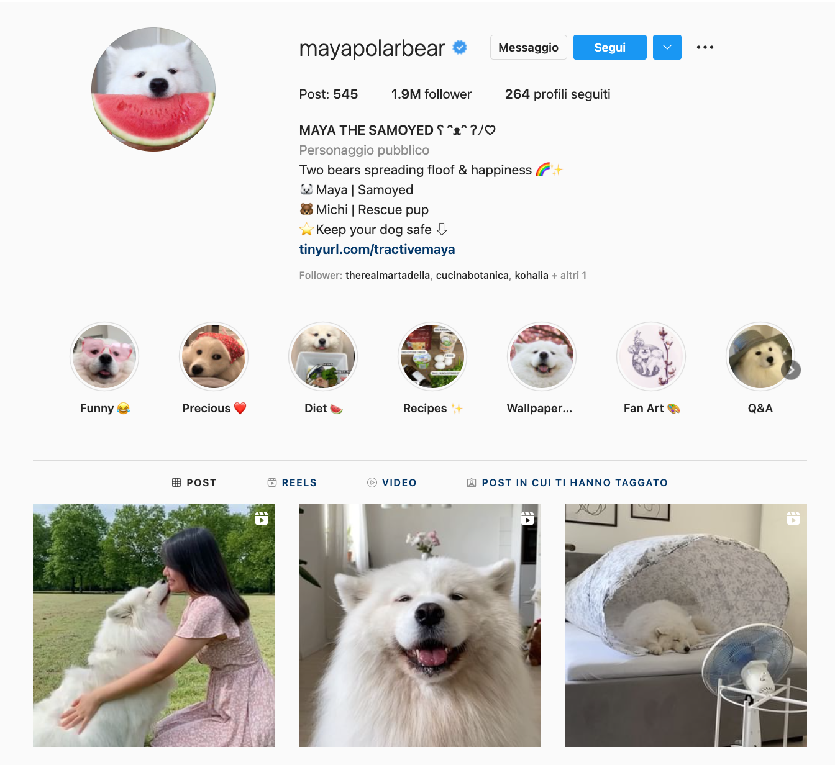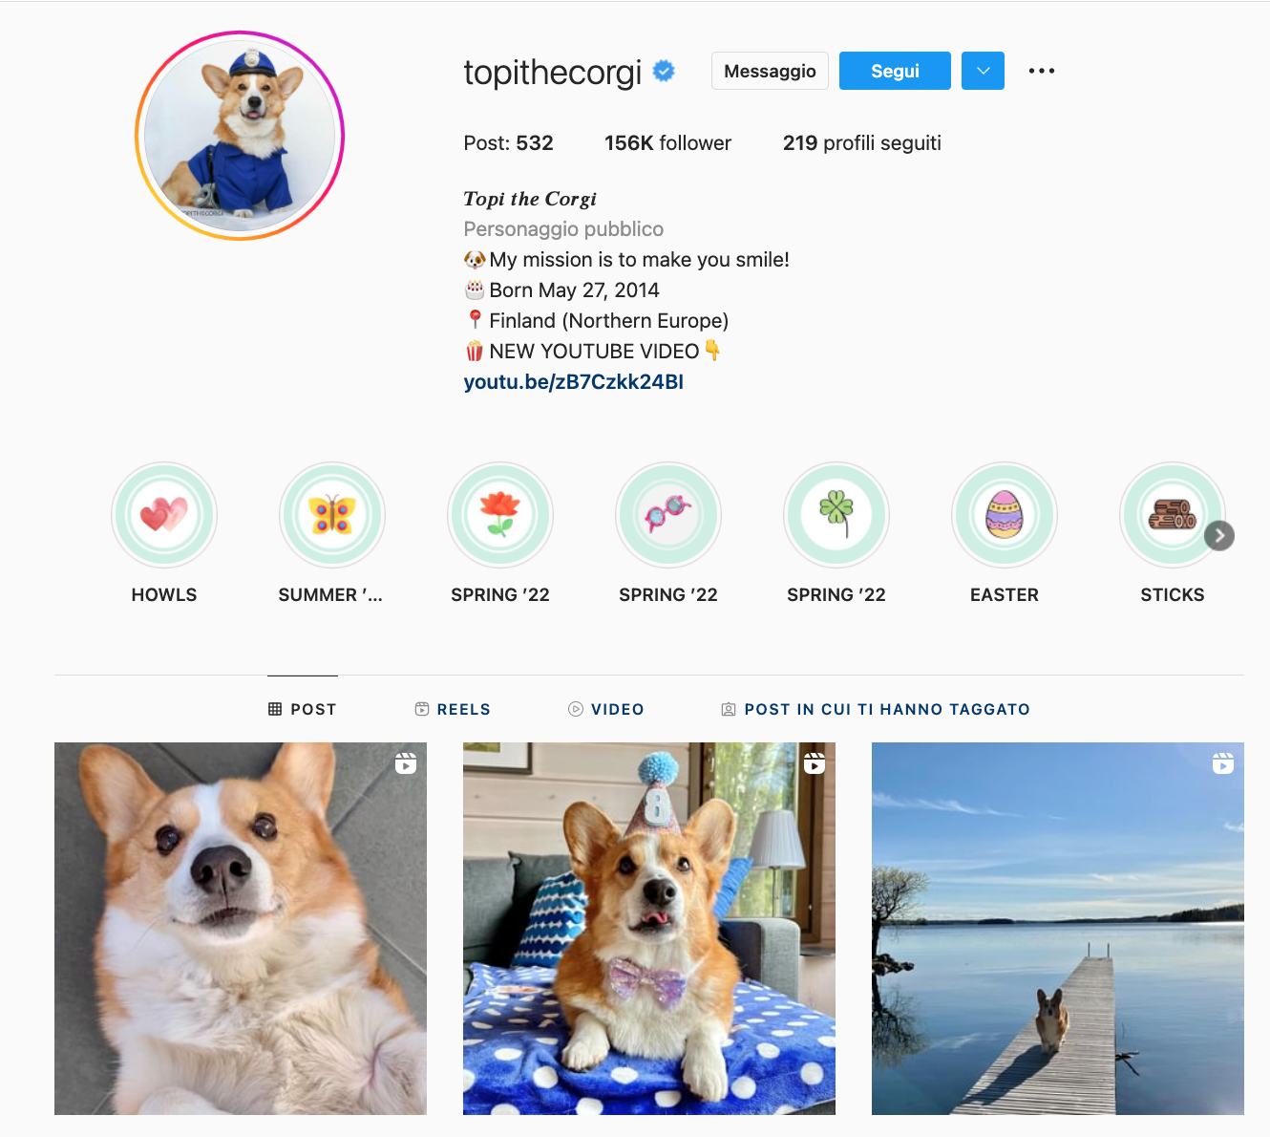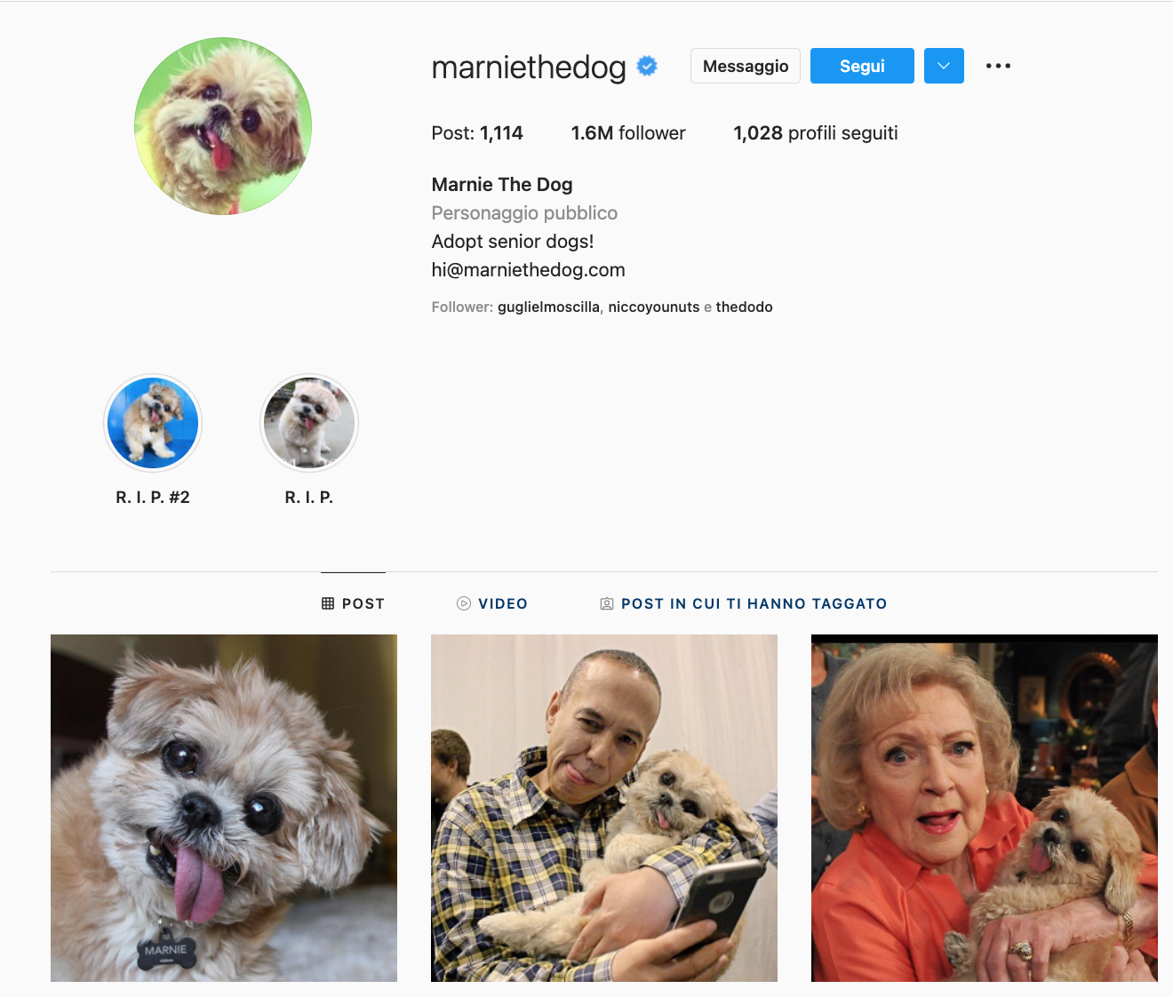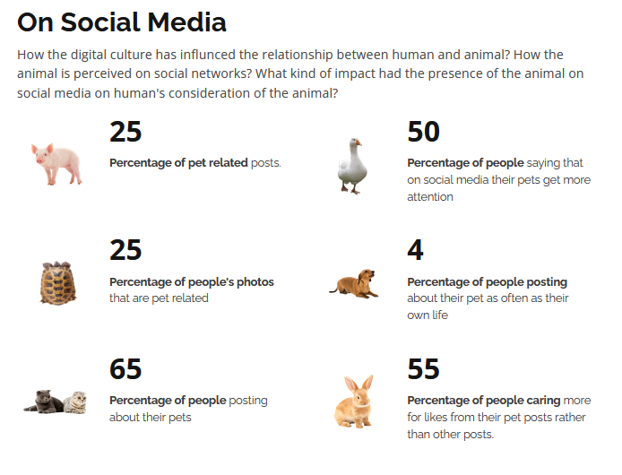

### Chosen cognitive focus among: 1.Attention-Distraction, 2.Language-Narrative, 3. Meaningfulness-Emotions-Empathy, 4. Authenticity perception, 5. Memory-Recall - 2nd step

We then could count on solid basis to go further with the idea of using the sentimental bond between a pet and its human to create a cultural initiative and a related interactive application based on the cognitive focuses of:

3. Meaningfulness-Emotions-Empathy, and

5. Memory-Recall

### Design cards

The (.....) designed by (.....) are a tool that we found very interesting and useful to fix our project in a more museological approach;

We then keep in the track of ideation

their use helped us to frame all the ideas in a certain standard and to define all the practical aspects of the work that had to be done. In this phase of ideation, we decided to continue to analyse and develop both the scenarios: that about a virtual initiative located in a real museum, and that about a virtual museum located exclusively online.

#### STAGE 2 – Define Institutional goal and relevant goals

The goals for both the institutions were quite similar (5/8) even if with different ranking: the to improve the educational contents and favorise the fruition through the user-own-device.

|  |  |
| --- | --- |
| Physical Museum | VE |
| 1. Increase visitor participation 2. Attract new demographics 3. **Increase online visits\*** | 1. Increase international reach 2. **Increase online visits\*** 3. Change visitor attitudes and beliefs* |

|  |  |
| --- | --- |
| Physical Museum | VE |
| * Change visitor attitudes and beliefs* * Use assets in new ways* * Increase repeat visits * Increase visitor feedback * Increase outreach* * Increase visitor spend | * Further social media reach * Attract new demographics* * Use assets in new ways* * Increase educational activities * Increase outreach* |

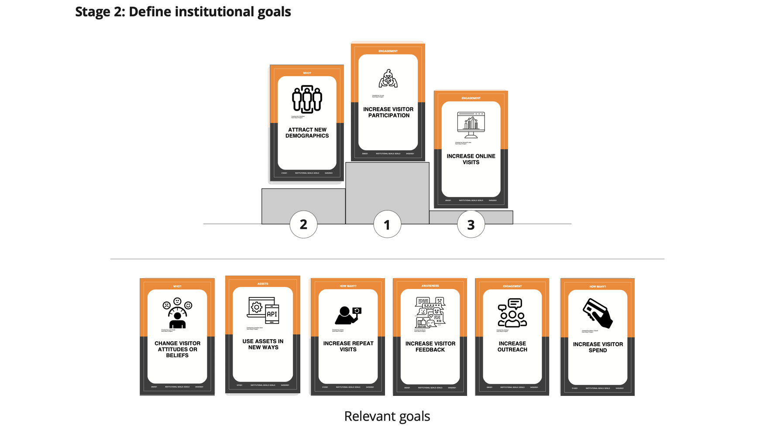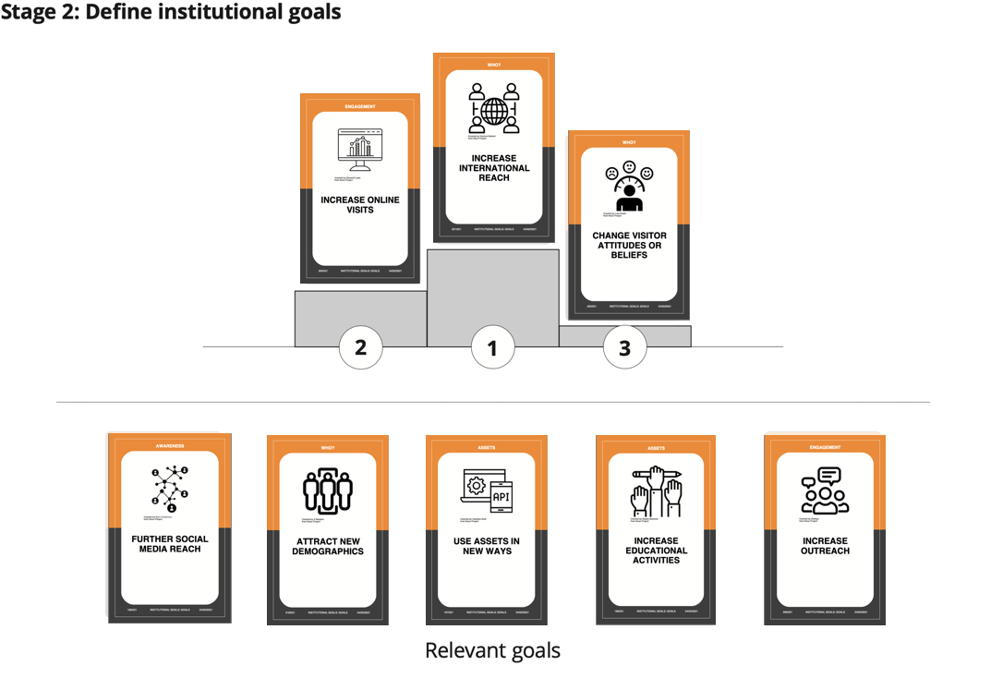

#### STAGE 3 – Create design brief

In the case of the physical museum, the app we thought about was an mobile-interaction based app through which the visitor could have higher interaction with the exhibit using its own smartphone or tablet.

In the case of the virtual museum the idea was different, but similar under some aspects: to develope

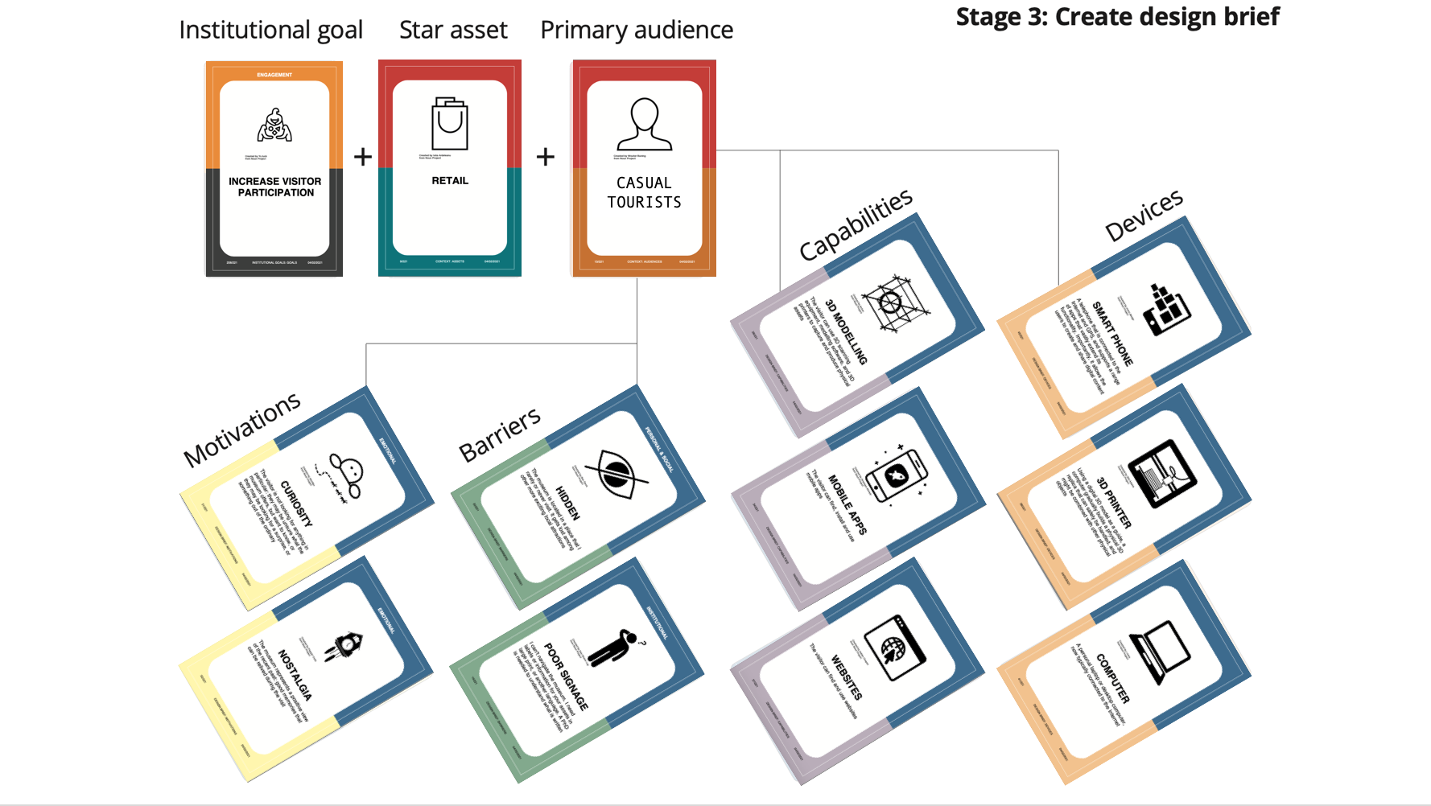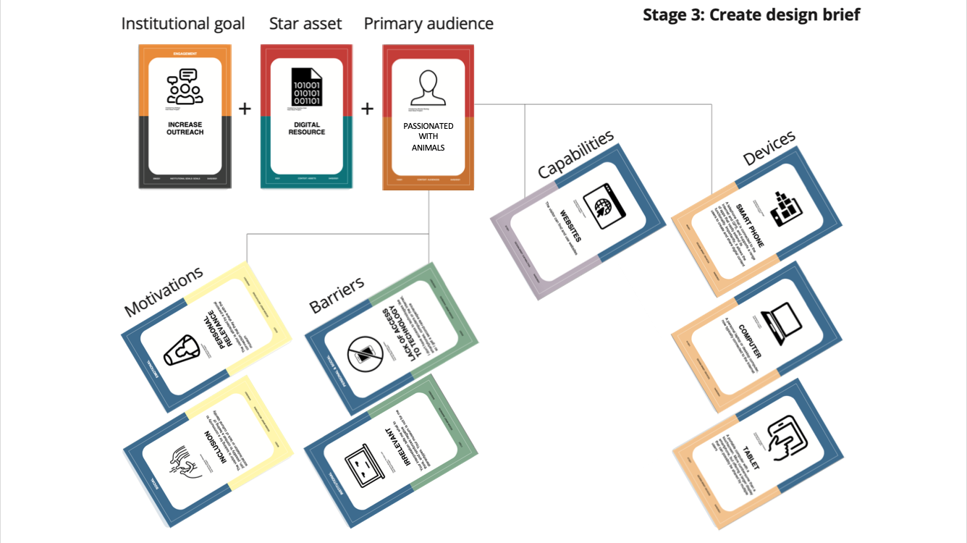

### Conceptual maps

|  |  |
| --- | --- |
|  |  |
| **CH topic** | **Museological approach** |

### The museological approach

We then started to think about the topic in a museological view trying to find the best way to translate it into a cultural journey.

Since the theme belongs to an emotional conceptuality, a good idea could be to express it through a story that accompanies the user as in a journey, articulated in simple steps repeated for every artist considered as:

1. A brief introduction on the pet artist story

2. More info about the artist

3. More info about the pet

4. The Artist’ room - Gallery: showing some of their work related to the human-pet bound

5. The Artist’ room - Work of art portraying the pet: showing the specific work of art

6. Further suggestions to know more about the topic

**The Virtual Exhibition**

We then created a “classic” Virtual Exhibition based on Omeka.net <https://canecane.omeka.net/>, a tool that allowed us to create a database of work of art, collections, and exhibition path, as well as to propose to the user advanced tools for search and browse through the items proposed.

To this scope, we completed the museological path for two pilot artists – Frida Kahlo and Giosetta Fioroni – while we limited just to list other possible artist-pet relationship to be explored (Pablo Picasso and Lump, Henry Matisse and Minouche, Andy Warhol and Archie, Salvador Dalí and Babou).

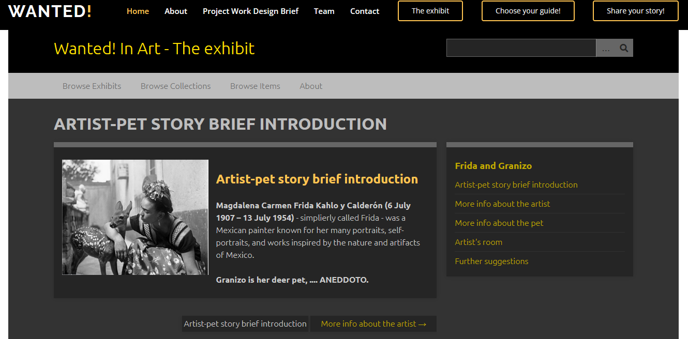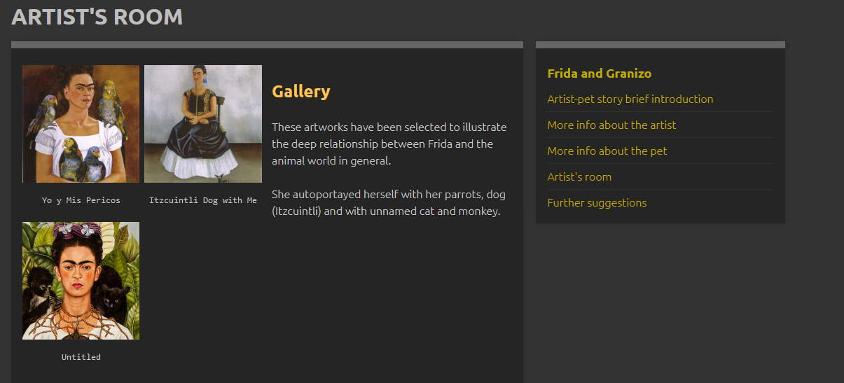

**The Interactive application and the 3d room**

We also devised a more interactive application “[Choose your guide](https://enri-ca.github.io/WANTED/ChooseGuide.html)” that give the possibility to explore a 3d exhibition with a freer path but with the help of a proper guide, instead of being autonomous in reading the critical parts and linearly scroll the contents; the guide will also suggest further activities at the end of the visit to engage more the user.

The 3d visit is then divided in rooms, accordingly with the path of the Virtual linear exhibition, each of which is dedicated to a different artist and its bond with their pet and other animals. The virtual room is showed as a real museum room (walls, sofa, paints with panels), the paintings have an interactive panel trough which (by clicking it) the user can visualize the work and go into detail.

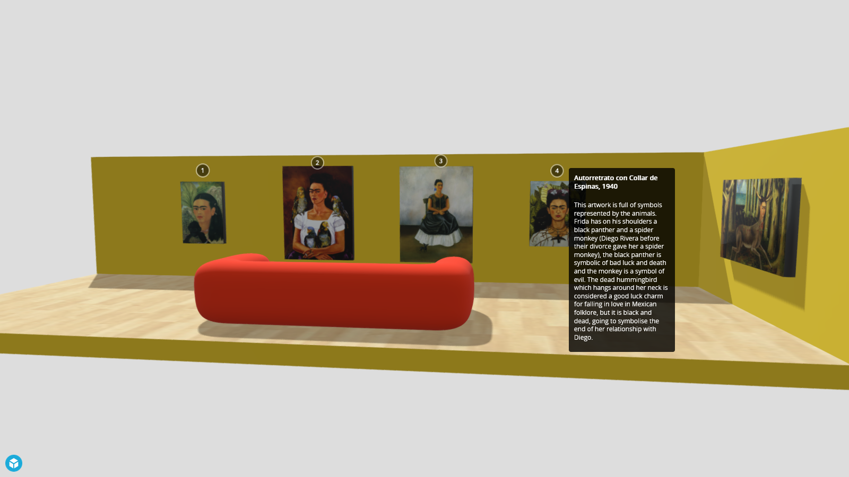

The information section showed by the panel is divided in some parts; a brief history of the artist, why we choosed him/her for our project and the analysis of most of the emblematic works that can be useful for the user to understand the importance of the animal in the creative processes of the artist.

we choose to insert inside the space are the most representative of a connection with an animal; each paint

#### Theoric classification

The VE and the related applications, whose details will be discussed in the Development section, having engagement and education as primary goals, can be classified in the E or F category, according to Simona Caraceni taxonomy:

|  |  |
| --- | --- |
| NEED | Interpretaton - Experimentation/complex museum identity |
| INTERACTION | Open |
| SPACE | Open |
| CONTENT | Selected works - Photograph, books, paintings, geo--- |
| VIRTUAL/REAL | Virtual with real/Virtual with virtual |
| VISITORS CONTRIBUTIONS | Allowed |

E) Virtual museum that enhance museum objects INTERPRETATION with OPEN INTERACTION in an OPEN SPACE showing SELECTED (or ALL OBJECTS) of the museum collection, ALLOWING visitor CONTRIBUTIONS.   
F) Virtual museum making EXPERIMENTS with NEW MUSEOLOGICAL MODELs with OPEN INTERACTION in an OPEN SPACE showing SELECTED (or ALL OBJECTS) of the museum collection, ALLOWING visitor CONTRIBUTIONS.

at the end of which the user is free to express his personal story.

The steps that the user encounter during the journey were chosen on the base of the educational and sentimental goal that this project want to reach.

### QUI VA AGGIUNTO UN PICCOLO RIASSUNTO SU: TARGET, SPACE, GOALS, APPROACH

## Goals (cultural, cognitive, economic, educational, etc.)

As we have seen in the development of the institutional goals, the virtual exhibition and the related applications cover several goals in different areas.

In particular,

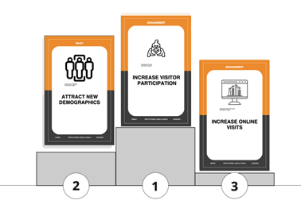

Economic: increase online visits and connected merchandising (3d print your pet, Wanted! traiding cards and album, Guess Who Wanted! ed., etc.)

Cultural and educational: attract new demographics

Cognitive: increase visitor participation (new services as “Search for your pet”)

## Requirements

A requirement is something that your product should do or a quality it should have listed in accordance with its importance:

* MUST: involve the user, give educational content
* SHOULD: promote the museum
* COULD: improve
* WILL NOT: be as exhausting as the classical virtual exhibition, thought for a different public with more didactical infos and less interaction

They are defined from data on context, content, and people (and their needs).

# Development

## (a) The story (include an interactive narrative using Twine)

Our story tells about a young-adult visitor looking for a new approach art history exhibition. He or she finds the Wanted! website where it is possible to access a short historical preview in the In History section and a selection of pieces of art in the In Art section. She or he is emotionally involved due to their childhood and recent souvenirs about their pets. They enjoy the exhibition, they gain more knowledge and they are happy to contribute at Your stories section with their pets' stories. Moreover, they are happy and amused to realize a 3d rendering of their pet to be used in VR or AR and to be able to order for a 3d printed model of it to be gifted.

### PERSONAE

|  |  |
| --- | --- |
|  |  |

### SCENARIOS

|  |  |
| --- | --- |
|  |  |

## (c) experience design (from the users perspective) (include a diagram)???

## (b) Description of the interaction between the project and the users (include Interaction Diagram)

### Choose your guide

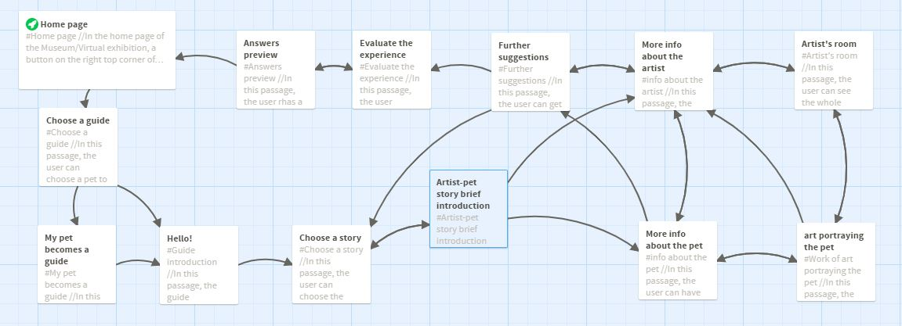

#### Intro steps

|  |  |  |
| --- | --- | --- |
|  |  |  |

#### VE steps

|  |  |  |
| --- | --- | --- |
|  |  |  |
|  |  |  |

#### Beyond the visit steps

|  |  |  |
| --- | --- | --- |
|  |  |  |

### Share your Stories

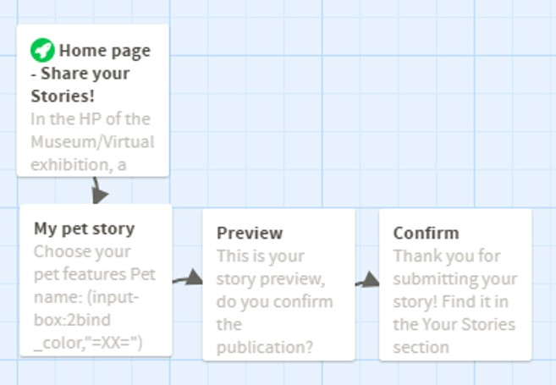

## ~~(c) Development to reach the cognitive focus~~

## (c) Foreseen workflow (includes needed software, hardware, professionals)

The actual realization of the sketched Virtual Exhibition and the related applications surely required a **multidisciplinary team** with professionals covering all aspects of issues related to contents or technical aspects; here just a probability incomplete list:

1. Art historian: to curate the scientific aspects of the exhibition and the related documentation
2. Art curator/gallerist/copyright lawyer: to face the copyright issues and possible request of reproduction
3. Pedagogist: to balance the contents and the language used according to the different target of the classical VE or the interactive app
4. a software developer – if not adopted a friendly software - in charge of the back-end;
5. Communication team and Social media manager: to curate the website and the social media and reach new public and realise marketing strategies
6. User experience expert and a 3d modeller: to realize 3d guides and 3d artists’ rooms
7. Someone with expertise in evaluating the impact and the feedback

For the realization of the pilot version of VE and the related applications, we used the following software and tools:

1. Github
2. Omeka.net
3. Blender
4. Twine
5. Zephir 3d

## (d) Further development and maintenance issues

### Search for your pet application

Further developments of the project include the forthcoming release of a tool “Search for your pet” able to help proactively people losing their pets by loading, sharing, and visualizing geolocated data of their missing pets. The user will have the possibility to fill in a form that will structure data in the correct way t

The proposed application is already announced under the Preliminary data section due to the fact that the announcement will have a similar structure and that it possible a user consulting that part will be …

### Merchandising

A strong accent will be put also on er merchandising proposing funny or educational items to be bought.

#### Wanted! Trading card and album

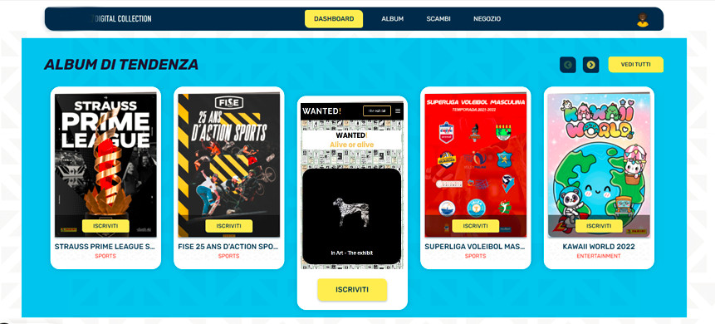

It could be useful to establish partnership and sponsorship as well as take advantage of services already sound in .

One example could be to create a collection of trading cards and related albums as those we can see from the <https://digitalcollection.mypanini.com/> website.

#### Wanted! Board games

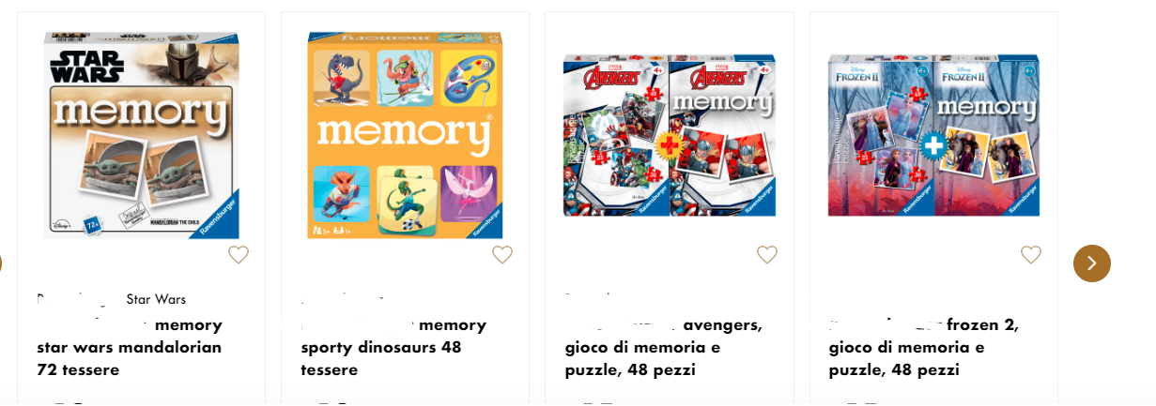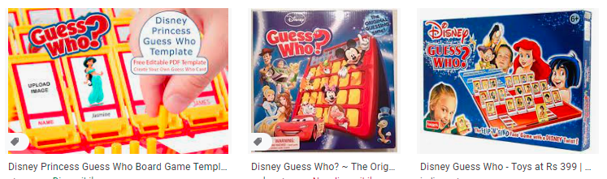

As several studies demonstrated that games and online applications could help children with difficulties to improve their learning outcomes and social interaction, the idea is to offer to the visitors traditional board games (and their online versions) thematized on the Wanted! Project.

### 3d print your pet

# Team roles

|  |  |
| --- | --- |
| Enrica Zani and Bigio | Alisia Zarbo |
|  |  |
| Basic idea and preliminary data section; physical museum analysis; Virtual Exhibition building with Omeka.net; application interaction diagram with Twine; merchandising ideation; privacy and copyright issues; bibliography | Ideation card; museological approach; social media analysis; Personae; Scenarios with Twine; Virtual Frida's room with Blender; feasibility plan. |

# Bibliography

## Intro

*A Cat Co-Authored an Influential Physics Paper*. <https://www.science.org/content/article/cat-co-authored-influential-physics-paper>. Accessed 22 June 2022.

Jérôme Michalon. ‘Causa animal y ciencias sociales Del antropocentrismo’. *Nueva sociedad*, no. 288, 2020, pp. 116–26.

Johnson, Daniel. *Yuri Knorozov: How a Soviet Scientist Managed to Decode the Mayan Writing - The Global Domain News*. 2 Feb. 2020, <http://www.globaldomainsnews.com/yuri-knorozov-how-a-soviet-scientist-managed-to-decode-the-mayan-writing>.

Lanjouw, Annette. *The Politics of Species : Reshaping Our Relationships with Other Animals*. 20130101.

Laurent-Simpson, Andrea. *Just like Family: How Companion Animals Joined the Household*. University Press, 2021.

‘List of Animals Awarded Human Credentials’. *Wikipedia*, 10 June 2022. *Wikipedia*, <https://en.wikipedia.org/w/index.php?title=List_of_animals_awarded_human_credentials&oldid=1092512160>.

scishenan. ‘Animal Co-Authors’. *Science Shenanigans*, 14 July 2017, <https://www.science-shenanigans.com/animal-co-authors/>.

WALSH, FROMA. ‘Human-Animal Bonds I: The Relational Significance of Companion Animals’. *Family Process*, vol. 48, no. 4, 2009, pp. 462–80. <https://doi.org/10.1111/j.1545-5300.2009.01296.x>.

---. ‘Human-Animal Bonds II: The Role of Pets in Family Systems and Family Therapy’. *Family Process*, vol. 48, no. 4, 2009, pp. 481–99. <https://doi.org/10.1111/j.1545-5300.2009.01297.x>.

## Project

* Caraceni taxonomy
* Caraceni Mewseografy
* Quelli della classificazione museale
* Haraway. *The Companion Species Manifesto: Dogs, People, and Significant Otherness*, 2003

## In History section (vedere se riusciamo a richiamare le bibliografie dei modals)

* Arluke, Arnold., and Lauren. Rolfe. *The Photographed Cat Picturing Human-Feline Ties 1890-1940*. First ed. 2013.
* *Dogs & Cats in Art Wednesday, 22nd January 1997*. London: Bonhams, 1996. https://almastart.unibo.it/permalink/f/10694hg/39UBO_SEBINA_DSUBO3965883

## In Art section

* Barbara Amadasi. "Animal Farm." *Vogue (Italia)*, no. 716 (2010): 74. https://almastart.unibo.it/permalink/f/pt4j7f/TN_cdi_proquest_miscellaneous_1847846888
* Fioroni, Giosetta. *Dog*. Corraini, 2010.
* https://www.albludiprussia.com/giosetta-fioroni-e-linvenzione-della-famiglia/
* Boltanski, Christian, Fabio Malossi, Beppe Sebaste, Bologna, and Museo per La Memoria Di Ustica Bologna. [*Lista Degli Oggetti Personali Appartenuti Ai Passeggeri Del Volo IH 870*](https://almastart.unibo.it/permalink/f/10694hg/39UBO_SEBINA_DSUBO2411850). S.l: S.n, 2007.

# Complementary Material for the Discussion

## 3d object or scene (3D): Frida room’s

## ~~Trailer (video)--> NO~~

## ~~Audio (i.e. interviews of your potential users) --> NO~~